Cross-quantilogram: EURUSD and USDCAD
Method 20 / daily log returns / expanding quantiles / Alpari D1 full available history

Study setup
Logical pair: EURUSD , USDCAD
Broker symbols: EURUSD_i , USDCAD_i
Snapshot: 2026-11-03_majors_alpari_D1
Timeframe: D1
Matched return window: 1999-01-05 to 2026-11-02 (UTC bar dates)
Matched return count n: 7188
Dropped unfinished last bar dated 2026-11-03 UTC after a tick-volume check against the prior complete day.
Quantiles: expanding window, min history 252 days
tau in [0.05, 0.2]; k=0..10; headline tau=0.05, k=1
Complete matched rows (Excel): EURUSD-USDCAD_CQ_D1.xlsx
Complete matched rows (HTML table): EURUSD-USDCAD_CQ_D1_data.html

Method carried forward
The cross-quantilogram rho_tau(k) measures linkage among centered quantile-hit indicators of matched daily log returns of close, ln(close_t / close_t-1). Quotes are not inverted. At each date t, the tau-quantile uses only returns through t (expanding window) after a minimum history of 252 days. Hits are h_t = 1(r_t < q_t) - tau. rho_tau(k) is the normalized cross-product of h_x,t with h_y,t+k. Levels tau in {0.05, 0.20} and lags k=0..10 are pre-specified; headline is tau=0.05, k=1 both directions. Same-sample Pearson r is a side check. This is not causation and not a trading signal.

Results (headline)
rho_EURUSD->USDCAD(tau=0.05,k=1): 0.063895
rho_USDCAD->EURUSD(tau=0.05,k=1): 0.038452
rho_EURUSD->USDCAD(tau=0.20,k=1): 0.032822
rho_USDCAD->EURUSD(tau=0.20,k=1): 0.023892
Pearson r: -0.456626

CQ table (tau=0.05)
k | rho_EURUSD_to_USDCAD | n_EURUSD_to_USDCAD | rho_USDCAD_to_EURUSD | n_USDCAD_to_EURUSD
0 | -0.02988188 | 6937 | -0.02988188 | 6937
1 | 0.06389479 | 6936 | 0.03845203 | 6936
2 | 0.02066515 | 6935 | 0.02045818 | 6935
3 | 0.06027616 | 6934 | 0.02764353 | 6934
4 | 0.02785119 | 6933 | 0.04562033 | 6933
5 | 0.04945365 | 6932 | 0.01683462 | 6932
6 | 0.05664891 | 6931 | 0.03121448 | 6931
7 | 0.03142688 | 6930 | 0.03120578 | 6930
8 | 0.0278162 | 6929 | 0.00241914 | 6929
9 | 0.06382746 | 6928 | 0.013202 | 6928
10 | 0.0386048 | 6927 | 0.0527635 | 6927

Conclusion
Headline tau=0.05, k=1 for EURUSD and USDCAD: rho_EURUSD->USDCAD = 0.0639; rho_USDCAD->EURUSD = 0.0385. At tau=0.20, k=1: 0.0328 and 0.0239. Same-day tau=0.05 rho(k=0) = -0.0299. Pearson r = -0.4566. This is quantile-hit linkage, not a trading signal.

Charts
Daily closes

Daily log returns

Cross-quantilogram tau=0.05
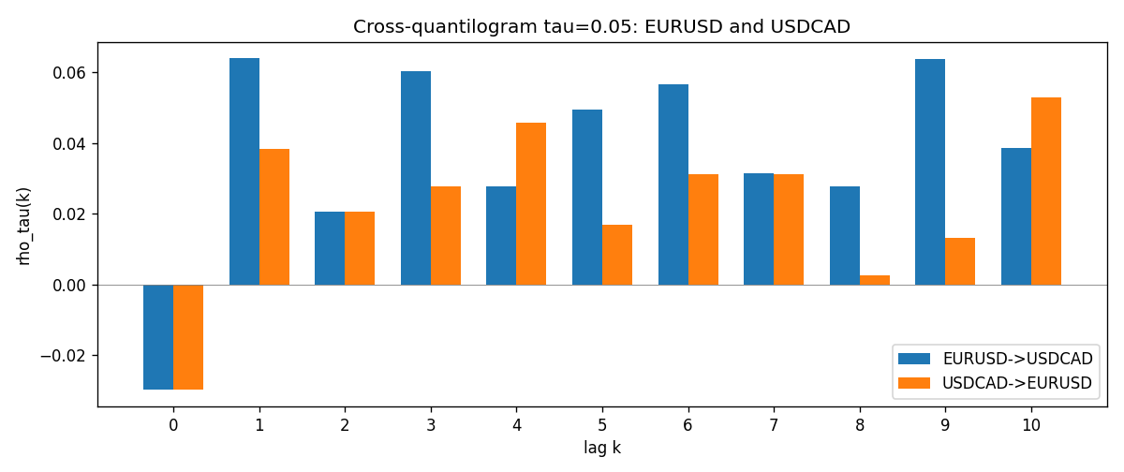

Data report
Matched rows and the CQ sheet are in the sibling Excel workbook named EURUSD-USDCAD_CQ_D1.xlsx. Embedding all rows as a Word table is impractical; this file holds column summaries and the first and last 15 matched rows.
Columns: time, EURUSD_open, USDCAD_open, EURUSD_high, USDCAD_high, EURUSD_low, USDCAD_low, EURUSD_close, USDCAD_close, EURUSD_tick_volume, USDCAD_tick_volume, EURUSD_spread, USDCAD_spread, EURUSD_real_volume, USDCAD_real_volume, EURUSD_log_return, USDCAD_log_return, EURUSD_h_t005, USDCAD_h_t005
Column summaries (matched calculation rows)
column | count | mean | std | min | 25% | 50% | 75% | max
EURUSD_open | 7188 | 1.1814345 | 0.15078289 | 0.8272 | 1.086195 | 1.16617 | 1.2939425 | 1.5995
USDCAD_open | 7188 | 1.2667783 | 0.16890181 | 0.9168 | 1.1183975 | 1.298465 | 1.37211 | 1.6183
EURUSD_high | 7188 | 1.1865652 | 0.15138546 | 0.8326 | 1.0902775 | 1.17128 | 1.2993025 | 1.6038
USDCAD_high | 7188 | 1.2716763 | 0.16885945 | 0.9336 | 1.12285 | 1.30387 | 1.37649 | 1.619
EURUSD_low | 7188 | 1.1764236 | 0.15010221 | 0.8227 | 1.0820675 | 1.16257 | 1.2883725 | 1.5865
USDCAD_low | 7188 | 1.26222 | 0.16893673 | 0.9056 | 1.114065 | 1.293535 | 1.367805 | 1.6102
EURUSD_close | 7188 | 1.181473 | 0.1507571 | 0.8267 | 1.0860725 | 1.166175 | 1.2939575 | 1.5997
USDCAD_close | 7188 | 1.2667932 | 0.16887388 | 0.916 | 1.118295 | 1.29844 | 1.372365 | 1.6137
EURUSD_tick_volume | 7188 | 103177.84 | 173518.96 | 218 | 9407.75 | 52764 | 99553.25 | 1471626
USDCAD_tick_volume | 7188 | 81016.727 | 147303.02 | 37 | 5545 | 40941.5 | 71627 | 1410818
EURUSD_spread | 7188 | 19.349471 | 16.556644 | 0 | 8 | 12 | 30 | 50
USDCAD_spread | 7188 | 23.444073 | 18.266035 | 0 | 9 | 17 | 40 | 60
EURUSD_real_volume | 7188 | 4.031926e+10 | 1.6689501e+11 | 0 | 0 | 0 | 0 | 3.6149665e+12
USDCAD_real_volume | 7188 | 1.8376704e+10 | 9.6688094e+10 | 0 | 0 | 0 | 0 | 2.5751613e+12
EURUSD_log_return | 7188 | -7.59e-06 | 0.00580128 | -0.03123819 | -0.0032472 | 0 | 0.00325412 | 0.03433183
USDCAD_log_return | 7188 | -1.518e-05 | 0.00514306 | -0.03859748 | -0.00283637 | 4.741e-05 | 0.00272353 | 0.03436319
EURUSD_h_t005 | 6937 | -0.0167003 | 0.17943096 | -0.05 | -0.05 | -0.05 | -0.05 | 0.95
USDCAD_h_t005 | 6937 | 0.00218394 | 0.22241382 | -0.05 | -0.05 | -0.05 | -0.05 | 0.95
First 15 matched rows (selected columns)
time | EURUSD_log_return | USDCAD_log_return | EURUSD_h_t005 | USDCAD_h_t005
1999-01-05 | -0.0048360507 | -0.010131666 | nan | nan
1999-01-06 | -0.011547966 | -0.0003306769 | nan | nan
1999-01-07 | 0.0076280636 | 0.0015202092 | nan | nan
1999-01-08 | -0.010902799 | -0.0020495197 | nan | nan
1999-01-11 | -0.007103287 | -0.0035137769 | nan | nan
1999-01-12 | 0.0045103728 | 0.0066194721 | nan | nan
1999-01-13 | 0.010845346 | 0.0045420214 | nan | nan
1999-01-14 | 0 | 0.0069376546 | nan | nan
1999-01-15 | -0.010153245 | -0.0056905671 | nan | nan
1999-01-18 | 0.0036256946 | 0.00098344542 | nan | nan
1999-01-19 | -0.00017235436 | 0.002748513 | nan | nan
1999-01-20 | -0.0031939256 | -0.0059646885 | nan | nan
1999-01-21 | 0.0030215416 | -0.0042823796 | nan | nan
1999-01-22 | -0.0012075213 | 0.0025057712 | nan | nan
1999-01-25 | -0.0030251979 | 0.00085579808 | nan | nan
Last 15 matched rows (selected columns)
time | EURUSD_log_return | USDCAD_log_return | EURUSD_h_t005 | USDCAD_h_t005
2026-10-13 | 0.0037402957 | -0.0046395653 | -0.05 | -0.05
2026-10-14 | -0.0037582255 | 0.0015184751 | -0.05 | -0.05
2026-10-15 | 0.0056053107 | -0.0036101503 | -0.05 | -0.05
2026-10-16 | 0.0017724895 | -0.0034322068 | -0.05 | -0.05
2026-10-19 | -0.0025394633 | -0.0018835331 | -0.05 | -0.05
2026-10-20 | 0.0023881672 | -0.0037066008 | -0.05 | -0.05
2026-10-21 | -0.00032046717 | -0.00084691787 | -0.05 | -0.05
2026-10-22 | -0.0015949606 | -0.0026307268 | -0.05 | -0.05
2026-10-23 | -0.001338521 | 2.85545e-05 | -0.05 | -0.05
2026-10-26 | -0.0022706559 | 5.7106554e-05 | -0.05 | -0.05
2026-10-27 | -0.004152342 | 0.0025379458 | -0.05 | -0.05
2026-10-28 | 0.0022262927 | -0.0038379274 | -0.05 | -0.05
2026-10-29 | 0.0022571351 | -0.00011436495 | -0.05 | -0.05
2026-10-30 | -0.0011458446 | -0.0010298736 | -0.05 | -0.05
2026-11-02 | 0.002120569 | 0.00061519094 | -0.05 | -0.05

